Dear 2020-2021 FBHS AP Calculus Students,

Wow, what a way to end the 2019-2020 school year, right? I pray that you all are doing well, your families are doing well, and that you are simply “hanging” in there as we wrap up the school year. Please finish strong in your Precalculus class. Your teachers are introducing vectors to you which are important to physics and BC calculus so don’t quit yet!

What you will find on the following pages is my usual summer assignment for AP Calculus students. It consist of numerous algebra and trig. topics that appear in our Calculus content with which you need to be comfortable. I have due dates posted on the next page, and we will take an “Algebra Test” over these review concepts on the day listed. I have given you my email address for communication purposes.

Now, I am writing all of this with the assumption that we will start school on Aug. 7th as planned in the building, but that might not be the case. We could possibly start school “online” or the start date could be pushed back. We will have to wait and see what Hall County Schools decides is best for our system. So to prepare for alternative “start modes” for the 20-21 school year, I am going ahead and making a “Remind” for you all.

**- If you are registered for the block class, please join my remind using the**

**code: @blockabbc**

**-If you are registered for the year long AB class, please join my remind  
 using the code: @abcallack**

I promise that I will not send you any messages/texts until August. If you have questions over the summer assignment during the months of June/July feel free to message me with Remind to ask your questions. I just want to be able to start communicating with you in August especially if the start day is delayed – I will have to adjust due dates, etc. I probably won’t be able to communicate with you via Canvas until August.

Anywhoo – I look forward to next school year getting back to normal, meeting you all, and working with you to master Calculus with hopes of getting a 5 on the AP exam! Take care and enjoy your time off.

Mrs. Lackey

FBHS AP Calculus Teacher

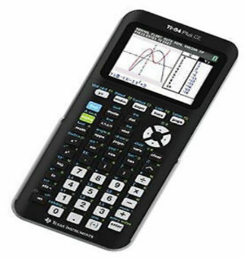Oh, you are going to **need** a graphing calculator for AP Calculus. This is what I recommend: **TI-84 Plus CE**. If you don’t have one, be watching for back-to-school sales in July – that is when they are the cheapest!

**AP Calculus AB/BC Summer Assignment**

**Block AB/BC Due Date: Tuesday, August 11, 2020**

**Algebra Review Test on August 11th**

**Year-long AB Due Date: Thursday, August 13, 2020**

**Algebra Review Test on August 13th!**

**The purpose of this assignment is to refresh your memory of algebra and pre-calculus topics that must be mastered before learning calculus. To be successful in Calculus, you must have great algebra skills. All problems must be worked out *neatly* on this paper. All answers should be real numbers (no imaginary answers).**

**All Problems should be worked without using a calculator.**

**Should you need help with any of these problems, you may stop by**

**during preplanning (August 3rd – August 6th). Email me at** [**melodee.lackey@hallco.org**](mailto:melodee.lackey@hallco.org) **and I will let you know the times that I will be available. A copy of this assignment will be posted on the school website link for summer assignments and the STEAM Canvas page if you lose this copy.**

**Your Algebra Review test will include a blank unit circle for you to complete. Make sure that you are prepared!**

**I hope you have a wonderful, restful summer break and come back in August  
 with a great work ethic and a positive mindset that you are going to be   
 successful in AP Calculus. I look forward to teaching you next year!!**

**Mrs. Lackey**

**AP Calculus AB/BC Algebra Review Name:______________________________**

**Factor completely:** **Use Factoring to Simplify. (Think about a GCF)**

1.  9. 

2.  10.

3.  11. 

4.  12. 

5. 

**Solve each equation by factoring:**

13. 

6. 

14.

7. 

15. 

8. 

**Simply:** **Rewrite without a fractional or negative exponent.**

16.  17.  23.  24. 

18. 19. 

25.  26. 

20.  21. 

22.  **Expand each of the following. (FOIL)**

27.  28. 

**Simplify, assume no variable equals zero:**

29.  30.  31.  32. 

**Simplify completely:**

33.  34.  35. 

**Find an equation of the line that passes through the given points.**

36.  37. 

**Find an equation of the line that passes through Find an equation of the line that passes through  
the given point and is perpendicular to the line the given point and is parallel to the line with the  
with the given equation. given equation.**

38.  39. 

**Graph each rational function. STATE holes, vertical and horizontal asymptotes and x and y intercepts**.

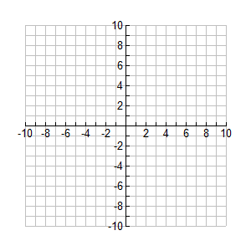40.  41.  42. 



**Graph each piecewise function.**

43.  44. 

45. **Sketch the parent graph of each of the following. State the domain and range of each parent graph.   
 Use interval notation to state the domain and range.**

A. . B. 

Domain: Domain:

Range: Range:



C. . D. 

Domain: Domain:

Range: Range:



E. . F. 

Domain: Domain:

Range: Range:



G. . H. 

Domain: Domain:

Range: Range:

I. . J. 

Domain: Domain:

Range: Range:

46. **Sketch the graph of each trig function below and state the domain, range and period of each. List  
 any asymptotes the graph may have. Be sure the label your axes.**

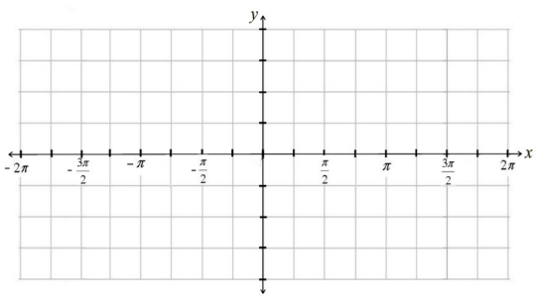A. . B  C. 

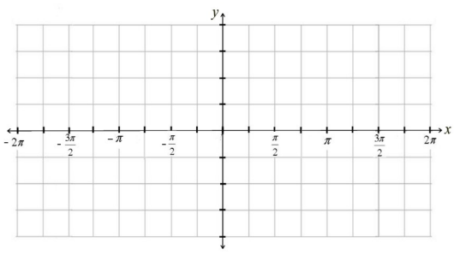

Domain: Domain: Domain:

Range: Range: Range:

Period: Period: Period:

47. **Sketch the graph of each trig function below and state the domain, range and period of each. List   
 any asymptotes the graph may have. Be sure the label your axes**

A. . B  C. 

Domain: Domain: Domain:

Range: Range: Range:

Period: Period: Period:

**For each pair of functions, find **

48. A.  B. 

**For each pair of functions, find **

49. A.  B. 

**Find the inverse of each function.**

50.  51.  52. 

**Use logarithms to solve each equation.**

53.  54. 

**Evaluate each expression without using a calculator.**

55.  56.  57.  58. 

59.  60. 

**Simplify without using a calculator.**

61. A.  B.  C.  D.

**Expand.**

62.  63. 

**Condense**.

64.  65. 

**\*\*\*Memorize your unit Circle again!!!** Be able to answer questions like the following.**

State the exact value of each of the following.

66.  67.  68. 

69.  70.  71. 