**AP Calculus AB/BC Summer Assignment**

**Block AB/BC Due Date: Friday, August 9, 2019**

**Algebra Review Test on August 9th**

**Year-long AB Due Date: Tuesday, August 13, 2019**

**Algebra Review Test on August 13th!**

**The purpose of this assignment is to refresh your memory of algebra and pre-calculus topics that must be mastered before learning calculus. To be successful in Calculus, you must have great algebra skills. All problems must be worked out *neatly* on this paper. All answers should be real numbers (no imaginary answers).**

**All Problems should be worked without using a calculator.**

**Should you need help with any of these problems, you may stop by**

**during preplanning (August 1st – August 6th). Email me at** [**melodee.lackey@hallco.org**](mailto:melodee.lackey@hallco.org) **and I will let you know the times that I will be available. A copy of this assignment will be posted on the school website link for summer assignments and the STEAM Canvas page if you lose this copy.**

**Your Algebra Review test will include a blank unit circle for you to complete. Make sure that you are prepared!**

**I hope you have a wonderful, restful summer break and come back in August  
 with a great work ethic and a positive mindset that you are going to be   
 successful in AP Calculus. I look forward to teaching you next year!!**

**Mrs. Lackey**

**AP Calculus AB/BC Algebra Review Name:______________________________**

**Factor completely:** **Use Factoring to Simplify. (Think about a GCF)**

1.  9. 

2.  10.

3.  11. 

4.  12. 

5. 

**Solve each equation by factoring:**

13. 

6. 

14.

7. 

15. 

8. 

**Simply:** **Rewrite without a fractional or negative exponent.**

16.  17.  23.  24. 

18. 19. 

25.  26. 

20.  21. 

22.  **Expand each of the following. (FOIL)**

27.  28. 

**Simplify, assume no variable equals zero:**

29.  30.  31.  32. 

**Simplify completely:**

33.  34.  35. 

**Find an equation of the line that passes through the given points.**

36.  37. 

**Find an equation of the line that passes through Find an equation of the line that passes through  
the given point and is perpendicular to the line the given point and is parallel to the line with the  
with the given equation. given equation.**

38.  39. 

**Graph each rational function. STATE holes, vertical and horizontal asymptotes and x and y intercepts**.

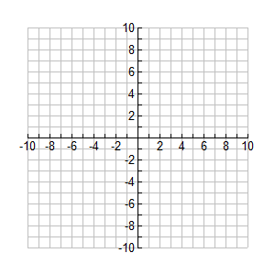40.  41.  42. 



**Graph each piecewise function.**

43.  44. 

45. **Sketch the parent graph of each of the following. State the domain and range of each parent graph.   
 Use interval notation to state the domain and range.**

A. . B. 

Domain: Domain:

Range: Range:



C. . D. 

Domain: Domain:

Range: Range:



E. . F. 

Domain: Domain:

Range: Range:



G. . H. 

Domain: Domain:

Range: Range:

I. . J. 

Domain: Domain:

Range: Range:

46. **Sketch the graph of each trig function below and state the domain, range and period of each. List  
 any asymptotes the graph may have. Be sure the label your axes.**

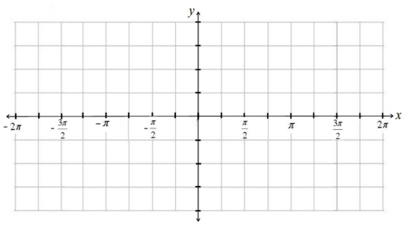A. . B  C. 

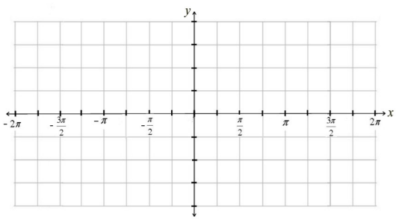

Domain: Domain: Domain:

Range: Range: Range:

Period: Period: Period:

47. **Sketch the graph of each trig function below and state the domain, range and period of each. List   
 any asymptotes the graph may have. Be sure the label your axes**

A. . B  C. 

Domain: Domain: Domain:

Range: Range: Range:

Period: Period: Period:

**For each pair of functions, find **

48. A.  B. 

**For each pair of functions, find **

49. A.  B. 

**Find the inverse of each function.**

50.  51.  52. 

**Use logarithms to solve each equation.**

53.  54. 

**Evaluate each expression without using a calculator.**

55.  56.  57.  58. 

59.  60. 

**Simplify without using a calculator.**

61. A.  B.  C.  D.

**Expand.**

62.  63. 

**Condense**.

64.  65. 

**\*\*\*Memorize your unit Circle again!!!** Be able to answer questions like the following.**

State the exact value of each of the following.

66.  67.  68. 

69.  70.  71. 